Waygate Technologies showcases advanced ultrasonic testing solutions at wire and Tube 2022

HUERTH, Germany, June 15, 2022 – Waygate Technologies, a Baker Hughes business and the world's leading provider of non-destructive testing (NDT) solutions for industrial inspection, will present its latest innovations in ultrasonic testing (UT) at the 2022 wire and Tube shows. The largest international trade fairs for the wire, cable, tube and pipe industries will take place in Düsseldorf, Germany from 20 – 24 June.
At Stand C04 in Hall 9, Waygate Technologies will showcase the following state-of-the-art UT models of the renowned Krautkrämer product line:
Krautkrämer ROWA™ Ux 400 mini – Less maintenance for more productivity
With Krautkrämer ROWA™ Ux 400 mini, an ultrasonic phased array inspection system that offers high precision and reliability, Waygate Technologies drives the inspectable diameter of steel bars down by 40% to the 6-25mm range. Thus, the NDT leader meets the increasing demand for ever more lightweight, high-strength steel parts in the automotive, mechanical engineering, and medical industries. Due to its robust, low-maintenance, rotating water jacket design, ROWA™ Ux 400 mini also offers the most simplified yet robust test mechanics on the market which allow for an easy handling and a maximum of uptime without any compromise on flaw detectability and reproducibility.
Krautkrämer USIP|xs CV – Automation tailored to all needs
Another flagship product that will be exhibited is the multi-channel flaw detector Krautkrämer USIP|xs CV. The scalable instrument platform for conventional ultrasonic (UT) inspections can be tailored to the individual requirements of fully automated or semi-automated systems and is easy to integrate and operate. USIP|xs CV is available in two versions, with a wide range of channel configurations making both scalable in performance to suit any kind of industrial application. While the multiplexed ESSENTIAL line is ideal for mid-range applications with a high channel count, from 2 up to 36 channels , the full parallel PERFORMANCE line was designed for demanding UT inspection use cases covering e.g. higher transmitter voltage and/or bandwidth.
WheelProbe 2 for Krautkrämer SNUP-LO – Upgrading pipe inspection
Visitors can also explore WheelProbe 2, the latest innovation for the ultrasonic inspection of weld seams in pipes. WheelProbe 2 is an upgrade for the Krautkrämer SNUP-LO ultrasonic testing machine by Waygate Technologies that allows for more production time – by reducing changeover time from 20 to 5 minutes – without compromising on quality. The on-bead probe reliably detects critical defects in submerged arc welds, such as transverse flaws and holes, with ultra-high resolution and at high speed. Due to its special rubber wheel design, it furthermore adapts to different weld shapes and thereby ensures comprehensive coverage, including in the heat affected zone.
Krautkrämer USM 100 – Redefining flaw detection
The Krautkrämer USM 100 is the new flagship handheld conventional UT flaw detector that takes accurate and repeatable ultrasonic inspections to the next level. In addition to market-leading UT capabilities, the Krautkrämer USM 100 sets new standards in ergonomics, connectivity and ruggedness, making it the go-to solution for users aiming to increase overall efficiency in their quality control. Its 7” high-resolution LCD display is glove-compatible and can be used under any lighting and weather conditions. Its low weight, various carrying options and the ability to switch between left- or right-handed operations further contribute to its well-balanced ergonomics, and the modern and intuitive interface with smartphone-like functionality additionally reduces training time.
The new Krautkrämer USM 100 also comes equipped for InspectionWorks, the agnostic inspection data management platform from Waygate Technologies. Paired with the InspectionWorks software, the USM 100 is the first digital native flaw detector that provides greater efficiency through remote access, data management and storage. Its array of sophisticated digital features include cloud-based data and fleet management, remote calibration, and the ability to be customized with apps available from either the public InspectionWorks store or customized workflows created for the fleet and shared through a private section of the store.

Learn more and contact Waygate Technologies about:
- Krautkrämer ROWA™ Ux 400 mini
- Krautkrämer USIP|xs CV
- WheelProbe 2 für Krautkrämer SNUP_LO
- Krautkrämer USM 100
- Waygate Technologies Website
- Waygate Technologies LinkedIn Channel
- Waygate Technologies YouTube Channel

Images
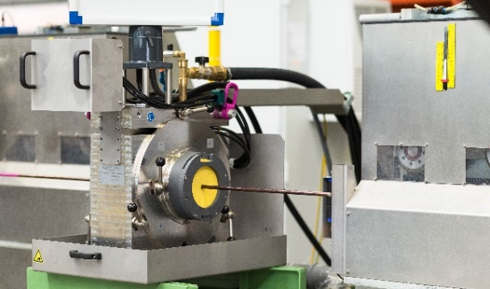
Krautkrämer ROWA™ Ux 400 mini
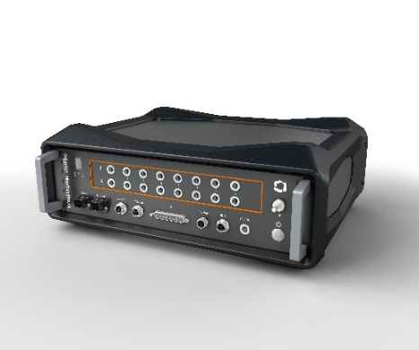
Krautkrämer USIP|xs CV

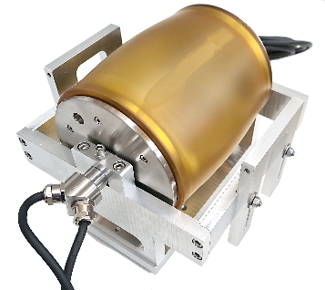
WheelProbe 2 for Krautkrämer SNUP-LO

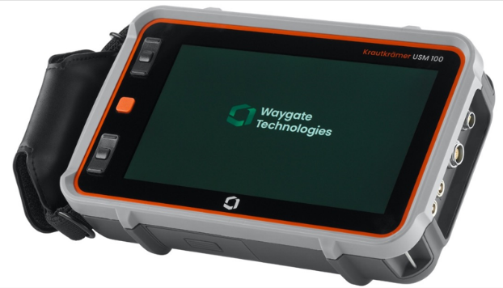
Krautkrämer USM 100

About Waygate Technologies
Waygate Technologies, a Baker Hughes business, is an industrial inspection solutions provider and the world leader in nondestructive testing (NDT) ensuring safety, quality and productivity. We combine more than 125 years of experience and a collection of heritage brands including Krautkrämer, phoenix|x-ray, Seifert, Everest and Agfa NDT. Today, hundreds of brands in the automotive, aviation, space exploration, electronics, energy, battery and additive industries trust our technologies. We drive digital transformation through a broad portfolio of award-winning solutions in industrial radiography and computed tomography (CT), remote visual inspection (RVI), ultrasound (UT), eddy current, and robotic inspection. Headquartered in Germany, Waygate Technologies is part of the Digital Solutions segment of Baker Hughes (NASDAQ: BKR). Inspection starts here: waygate-tech.com

Media Contact
Henning Juknat
Global Communications Leader
Waygate Technologies
+49 2233 601272
henning.juknat@bakerhughes.com

